Notes:
- Items in blue are notes and should not be read aloud.
- Items in red are roles in the ceremony, e.g., MC or First Reader. They can be substituted with the appropriate people’s names prior to printing.
- Items in black are to be read aloud.
- Delete any unused optional items prior to printing.

Members of the retirement team:
- Master of Ceremonies (MC)
- fire tender
- nine speakers to read the different parts of the script (8 Scouts plus either the SPL or an adult leader)

Equipment needed:
- Old flag(s) to be retired
- Bugler (optional)
- A long stick to make sure the flag stays in the fire as it burns and to stir the ashes when the burning is complete.

The flag retirement ceremony can be done in many settings, but is most effective in a small group setting. It should not be made a “grand event” or public display, rather a small, solemn occasion with a specific group or organization. A special ceremony or campfire would be appropriate. The actual ceremony should be an event by itself with no interruptions or “other business” during the ceremony. It may be a separate part of a larger program, but should have its own time from beginning to end.

NOTE: Before accepting a flag for retirement, the recipient should obtain information about its history. For example: Where has it flown? How long? Any memorable events happen at that site? This information should be used in the ceremony.

Cutting the flag prior to the ceremony
The corners of the flag should be stretched out over a table top and the flag cut on the black dashed lines per the following figure. Be careful not to cut up the blue star field. You will end up with four pieces of flag, one being the blue star field.

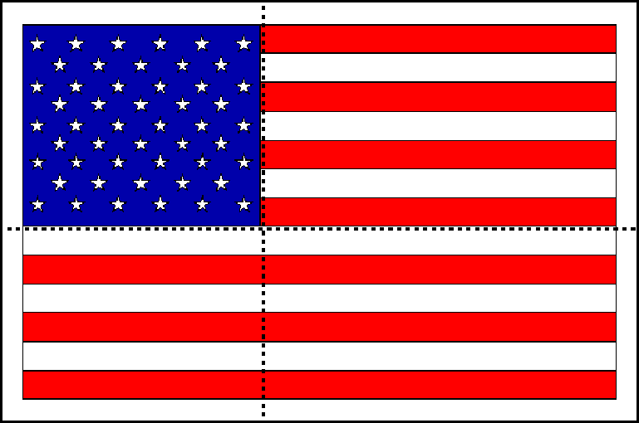

While the Scouts are cutting the flag, other Scouts should start and tend a medium size, wood fire (preferably in a metal drum or incinerator). Once the flag remnants and fire are ready, you perform the following ceremony. The Scouts maintain a vigil over the fire until all traces of the flag remnants are destroyed.

If the flag retirement is at the end of a campfire, the fire should be extinguished and the ashes buried. The burial can be completed with a moment of silence while taps is played by a bugler.

If the campfire will continue after the flag retirement, taps can be played while the flag is burned and the ashes buried later.

Have the audience or group form a half circle around the fire, leaving enough space for the people doing the flag retirement. Begin the ceremony by having the MC silence the crowd (“the sign is up”).

Delete these first two pages of instructions prior to printing.

Opening

MC: When the United States flag (Old Glory) becomes worn, torn, faded or badly soiled, it is time to replace it with a new flag, and the old flag should be "retired" with all the dignity and respect befitting our nation's flag. The traditional method of retirement is to incinerate the flag, but this does not mean that one should simply drop the entire flag (intact) into a fire.

A flag ceases to be a flag when it is cut into pieces. In addition, it is easier to completely incinerate the flag if it is cut into smaller pieces. A flag should never be torn up like an old bed sheet. It should be cut up with scissors in a methodical manner. We cut this flag into four pieces, one being the blue star field.

[Show the audience the pieces.]

MC: NOTE: The reason we do not cut the blue star field is it represents the union of the fifty states and one should never let the union be broken.

Adult Leader: The U.S. flag is more than just some brightly colored cloth... it is a symbol of our nation.

Scout #1: Seven red stripes and six white strips; together they represent the original 13 colonies that gained us liberty.

Scout #2: The red stripes remind us of the lifeblood of brave men and women who were ready to die for this, their country.

Scout #3: The white stripes remind us of purity and cleanliness of purpose, thought, word, and deed.

Scout #4: The blue is for truth and justice, like the eternal blue of the star-filled heavens.

Scout #5: The stars represent the fifty sovereign states of our union.

Adult Leader or SPL: The U.S. flag should be treated with respect when it's flying, and it should be treated with respect when it's being retired.

Scout #6: The American Creed states, “It is my duty to my country to love it, to respect its Constitution, to obey its laws, to respect its flag, and to defend it against all enemies.”

Scout #7: Therefore, we retire flags with dignity and respect when they become worn, torn, faded, or badly soiled.

Adult Leader or SPL: This flag is ready to be retired.

[If you know something about the flag you can add the following.]

Its history is as follows:
First raised (when):
At (location):
Memorable event or fact:

Scout #8: A flag ceases to be a flag when it is cut into pieces. We cut the flag into four pieces: three red and white striped banners and the blue star field. We leave the blue field intact because no one should ever let the union be broken.

Retiring the Colors

Adult Leader or SPL: As the parts of the flag are placed in the fire remember... Old Flags never die, they just get fired up!

MC: Scouts, hand salute!

Optional: The bugler plays taps OR the audience says the Pledge of Allegiance.

Place the flag into the fire, then step back from the fire, stand at attention and salute the flag.

The fire tender will use a long stick to make sure all parts of the flag burn and then stir the ashes so that it will be impossible to recognize the ashes as a flag.

MC: Two! The Scouts will maintain a vigil over the fire until no traces of the flag remnants remain. Then the ashes will be collected and buried.

MC: This concludes this ceremony.
If this is the end of the campfire:
MC: Thank you for attending.

