Images in the Scouting_Skills_and_Activities/knots Directory

The Knotting Dictionary of Kannet
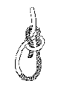  bowline_finish.gif  (117x162)  787B |  | 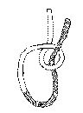bowline_starting.gif  (114x155)  822B | 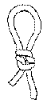  butterfly_finish.gif  (72x160)  682B
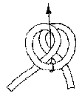  butterfly_starting.gif  (122x143)  901B |  | 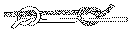  fishermans_knot.gif  (226x60)  727B | 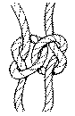  fknot.gif  (240x371)  4.0KB
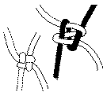  friend2.gif  (904x812)  10.5KB | 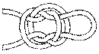  jug_sling_finish.gif  (190x105)  1.1KB | 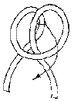  jug_sling_second.gif  (107x145)  973B | 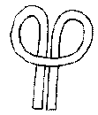  jug_sling_starting.gif  (121x142)  940B
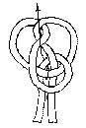  jug_sling_third.gif  (92x137)  831B |  | 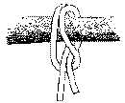  larks_head.gif  (156x129)  1.1KB | 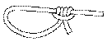  prusik.gif  (207x81)  670B
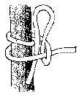  roundturn.gif  (116x140)  1.2KB | 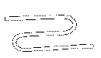  sheepshank_atarting.gif  (176x102)  422B |  | 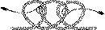  sheepshank_the_easy_way.gif  (289x84)  1.7KB
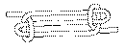  sheepshnk_finish.gif  (226x91)  716B | 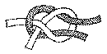  sheet_bend.gif  (188x95)  1.0KB |  | 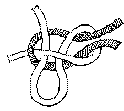  slip_sheet_bend.gif  (153x137)  1.1KB
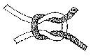  square_knot.gif  (192x120)  1.1KB |  |  | 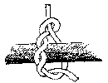  timber_hitch.gif  (145x112)  940B
 | 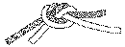  waterknot_finish.gif  (198x74)  831B | 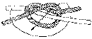  waterknot_starting.gif  (170x72)  867B | 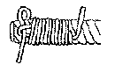  whiping_step2.gif  (150x95)  900B
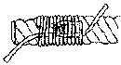  whiping_step3.gif  (149x80)  918B | 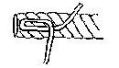  whipping_step1.gif  (142x81)  637B | 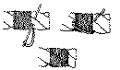  whip_style1.gif  (560x326)  6.0KB | 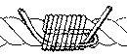  whip_style2.gif  (672x302)  6.2KB
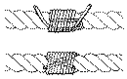  whip_style3.gif  (1088x677)  15.4KB | 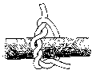  wrong_timber_hitch.gif  (120x93)  740B

The Knotting Dictionary of Kannet
Warning
None of these knots is considered 'safe' for climbing! The main purpose of this page is scouting, not climbing.
Reef Knot (Square Knot)
The knot everyone knows!!?! This is a knot for tying the ends of a piece of rope or string together, for example when tying up a parcel. Remember this is called a knot NOT a bend, as it should not be used for tying two ropes together, especially when your life depends on it, as it is easily spilt. Learn the knot by name one of the parts Bertil, and the other one Sture. When they fight, Bertil is stronger so he will get on the top. They twist, and the same thing happens again. Bertil gets on the top again. They twist again, and the reefknot is done.
Fisherman's Knot
For stiff rops and cords you shall use the Fisherman's Knot. Easy to make, dificult to untie, so don't use it on a good rope, especially if there is a lot of strain on it. You should make it double on cords of nylon, or it will not last.
Water Knot
A third knot for tying two ropes of the same thickness. Very strong knot, but difficult to untie. Good for tying grasses, wet rope, and rubber together (e.g. for repairing swimming goggles).
Sheetbend
The Sheetbend is a knot that you use to tie two ropes together. Good both for thick and thin ropes. Easy to untie. Use the Sheetbend (Becket Hitch) when you hoist a flag, and the loop already exist. The Slipped Sheetbend is even more easy to untie, just snatch the right end.
Lark's head
Very easy to do, it can be done even if both ends are tied. Both ends should have the same load, otherwise it will not be reliable. Use it when you want to tie a tarpaulin, where the holes exist.
Round Turn
Another simple but useful knot. Good to use when you are going to buy ice- cream, and have to tie your camel at the drain pipe. There are many variants of this knot.
Timber hitch
Another knot that is easy to do. It is important that you twist the free endaround itself. Check this by trying to adjust the size of the loop. If it is impossible, you have made a mistake!
Fisherman's Loop
A fixed loop. Quick to make. The name of the knot comes from the time when the fishermen could not write. Instead of a handwritten letter, the fisherman sen this knot home to his fiancee, with the two knots a bit separated. If it came back with the knots toghether, the answer was... YES!
Bowline
A fixed loop, very safe. You can use it when climbing and lifesaveing etc. If your life depends on this knot, you should do an extra knot to make it safer. Otherwise it will not be safe enough, especially if the rope is new. Often learnt by thinking of the end as a rabbit, and the loop as its hole, and as Elma Fudd would say: The wabbit gows up, out of his hole, wound the back of the twee, and back down into his buwwow!
Prussick
A very useful knot. The knot is an fixed loop, which you easily can resize, just by moving the knot. Suitable as a guy-line knot.
Clove hitch
A knot that is easy to make. Usable when you want to moor a boat. Do not use to tie something to a square post as it can easily come off.
Sheepshank
Use the sheepshank when you want to shorten a rope, or relieving tension from a worn piece of rope. You should load it, otherwise it won't be reliable. You can also fix it with a toggle etc.
Jug Sling Hitch
A very useful knot. In swedish it is called 'sack-knot from England', because the mealers used this knot to tie toghether the sacs. The loop is a useful handle, or you can use it as a hanger.
Whipping
Whipping is a good start if you want to learn about knotting. Use a thick thread, with different colours at each end of the rope. You need about 50 cm thread/end.

